 VINOD SIR’S GROUP TUTION

MARKS: 18 MATHS-II TIME: 1 Hr. 30 Mins.

DO AS DIRECTED

1. [2]

2. 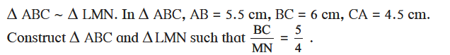
[3]

3. 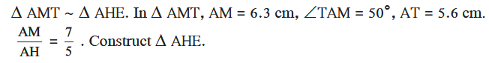
[3]

4. Draw a circle of radius 2.7 cm. Draw a tangent to the circle at any point on it. [2]

5. Draw a circle of radius 3.6 cm. Draw a tangent to the circle at any point on it without using the centre. [3]

6. Draw a circle of radius 3.3 cm Draw a chord PQ of length 6.6 cm. Draw tangents to the circle at points P and Q. Write your observation about the tangents [3]

7. Draw a circle with radius 4.1 cm. Construct tangents to the circle from a point at a distance 7.3 cm from the centre. [2]

